W I L D L I F E

CRUD Demo Project

|  |  |
| --- | --- |
|  | |
|  |  |
|  | |

NAY LA

TAble of  
Contents

**Introduction** 1

**Project Overview** 1

**CRUD Pages** 3

**Browser Compatibility Testing** 5

**Unit Testing on Application Controller** 6

**Database And Tables** 7

**Developer Tools** 10

# Introduction

This project is a simple task management application developed to meet the following requirements: to enable users to create, read, update, and delete tasks efficiently. The application features a user-friendly frontend interface that ensures an intuitive user experience while providing a robust backend for seamless data storage and management. By focusing on simplicity and usability, this application aims to enhance productivity and organization for users managing their tasks.

# Project

# Overview

This task management application consists of four main pages, each designed to enhance user interaction and provide essential functionalities. Below is a brief description of each page:

## 1. HOME PAGE

The **Home** page serves as the introduction to the application. It provides an overview of the project's purpose, features, and instructions on how to navigate through the application. Users are welcomed with a clear and concise layout that sets the tone for their experience.

## 2. ANIMALS PAGE

The **Animals** page displays a comprehensive list of animals. Users can perform CRUD (Create, Read, Update, Delete) actions on the animal records. This functionality allows users to manage the animal data effectively, ensuring that the information is up-to-date and relevant. The user-friendly interface makes it easy to navigate through the list and access the desired actions.

## 3. Animal Species page

The **Animal Species** page presents a list of various animal species. When a user clicks on a specific species, detailed information about that species is displayed. This page aims to educate users about different species and their characteristics, enhancing their understanding of wildlife.

## 4. Animal Habitat page

The Animal Habitat page showcases a list of different animal habitats. Similar to the Animal Species page, clicking on a specific habitat reveals detailed information. This functionality helps users learn about the environments in which various animals live and their ecological significance.

# CRUD Pages

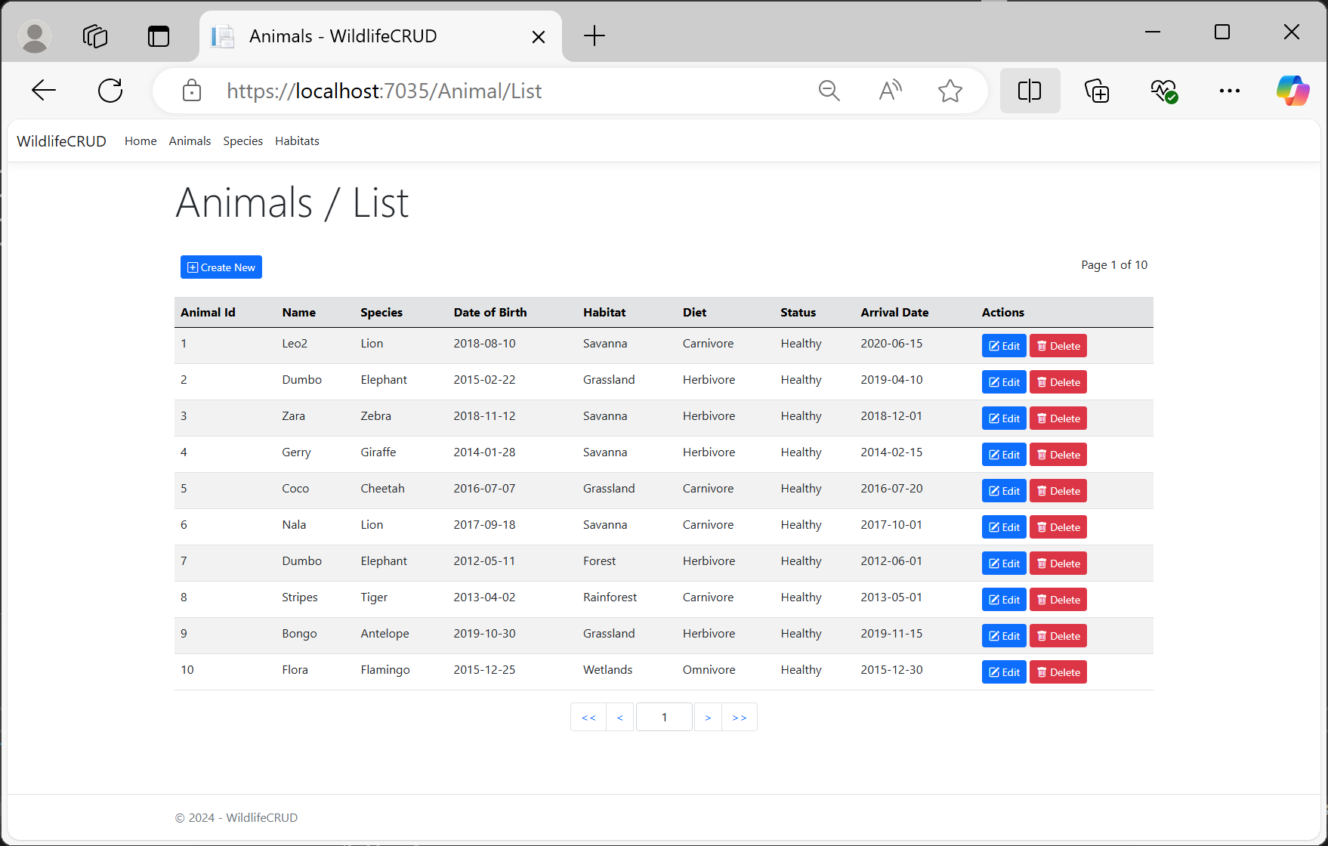

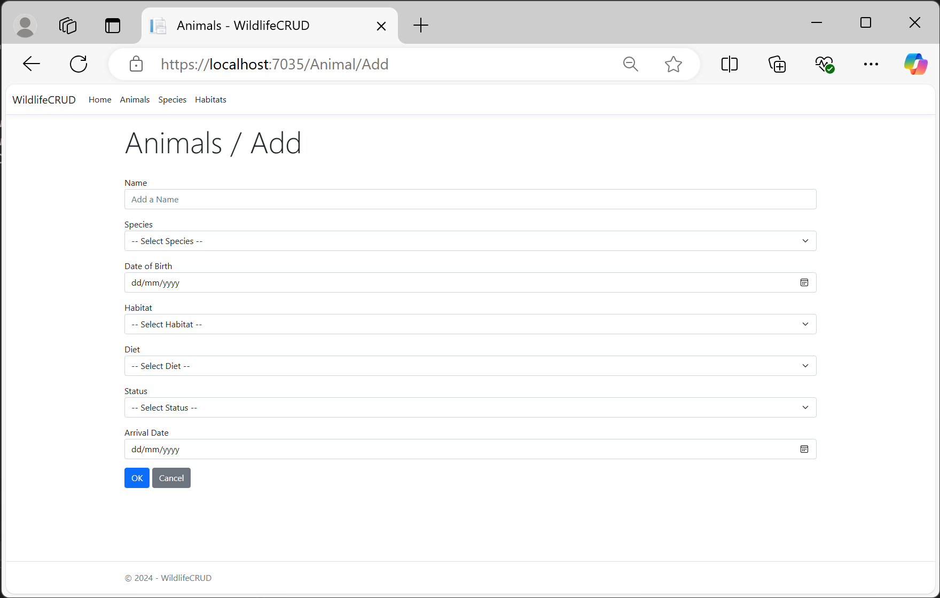

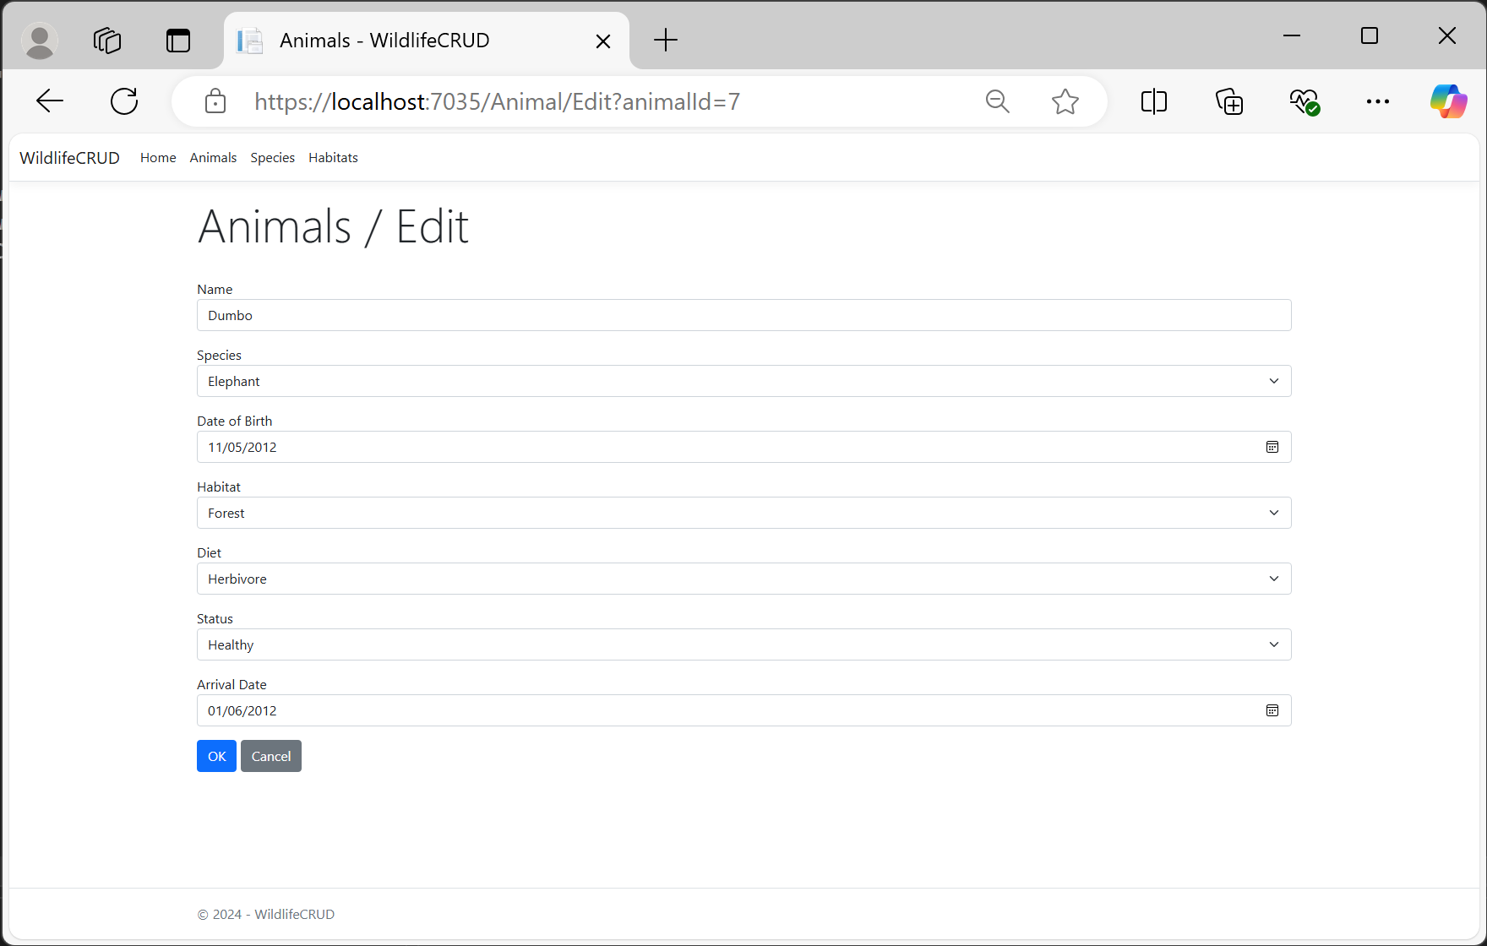

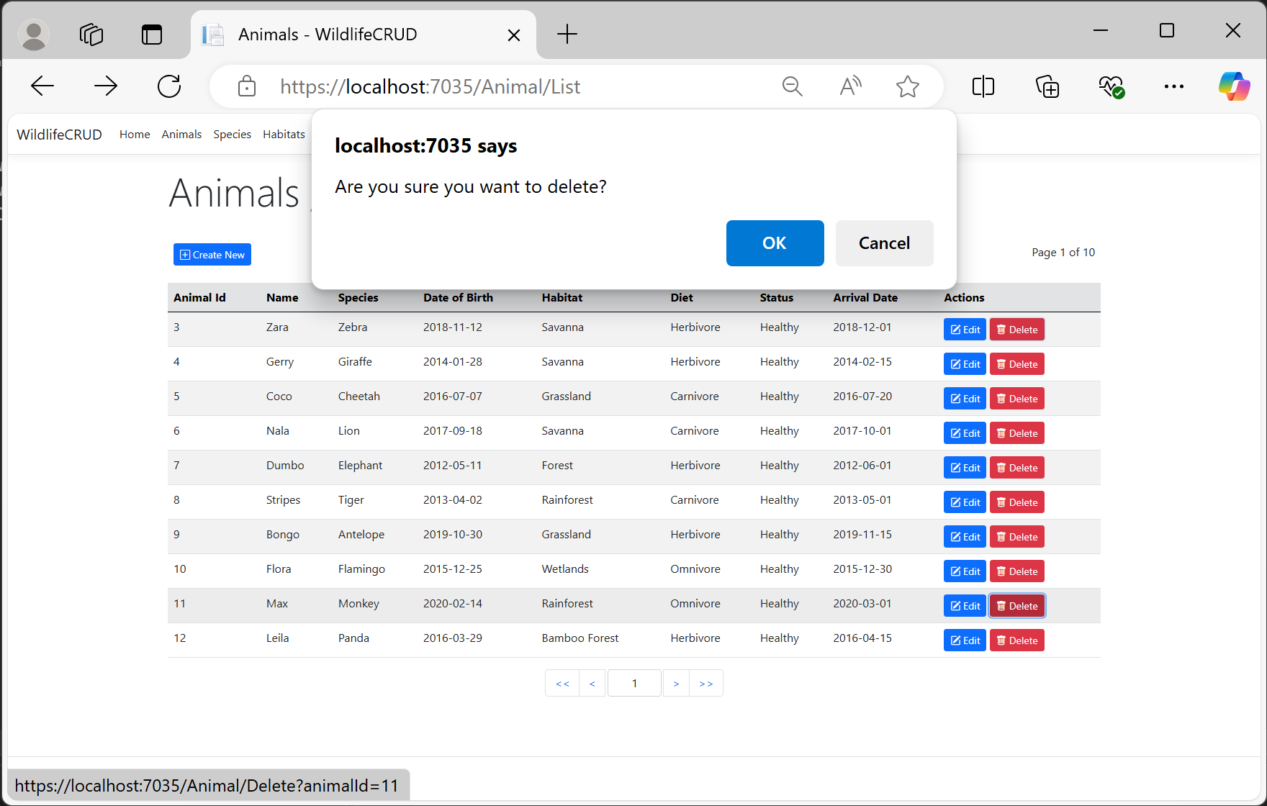

# Browser

# Compatibility Testing

To ensure a consistent and reliable user experience, the application was tested across multiple browsers, including:

* Microsoft Edge
* Google Chrome
* Mozilla Firefox

The application performed smoothly on all platforms, confirming its compatibility and responsiveness across different environments.

# unit Testing

# on APP Controller

***A sample unit test*** was created for the [AnimalController] to validate core functionalities, such as handling CRUD operations effectively. The test case executed without any issues, with all assertions passing successfully, confirming the reliability of the controller logic.

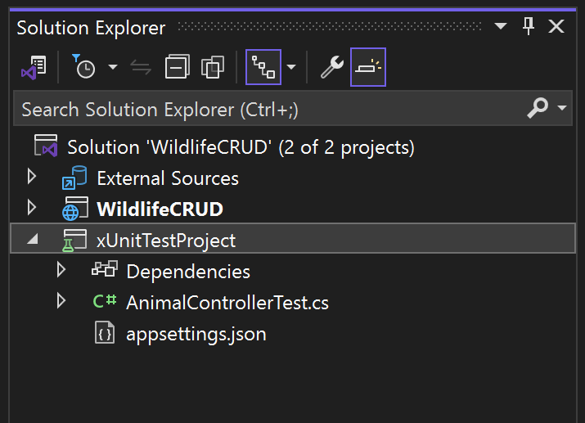

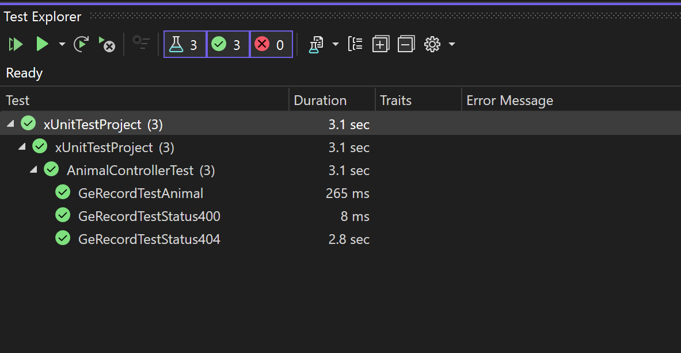

# Database

# and TABLES

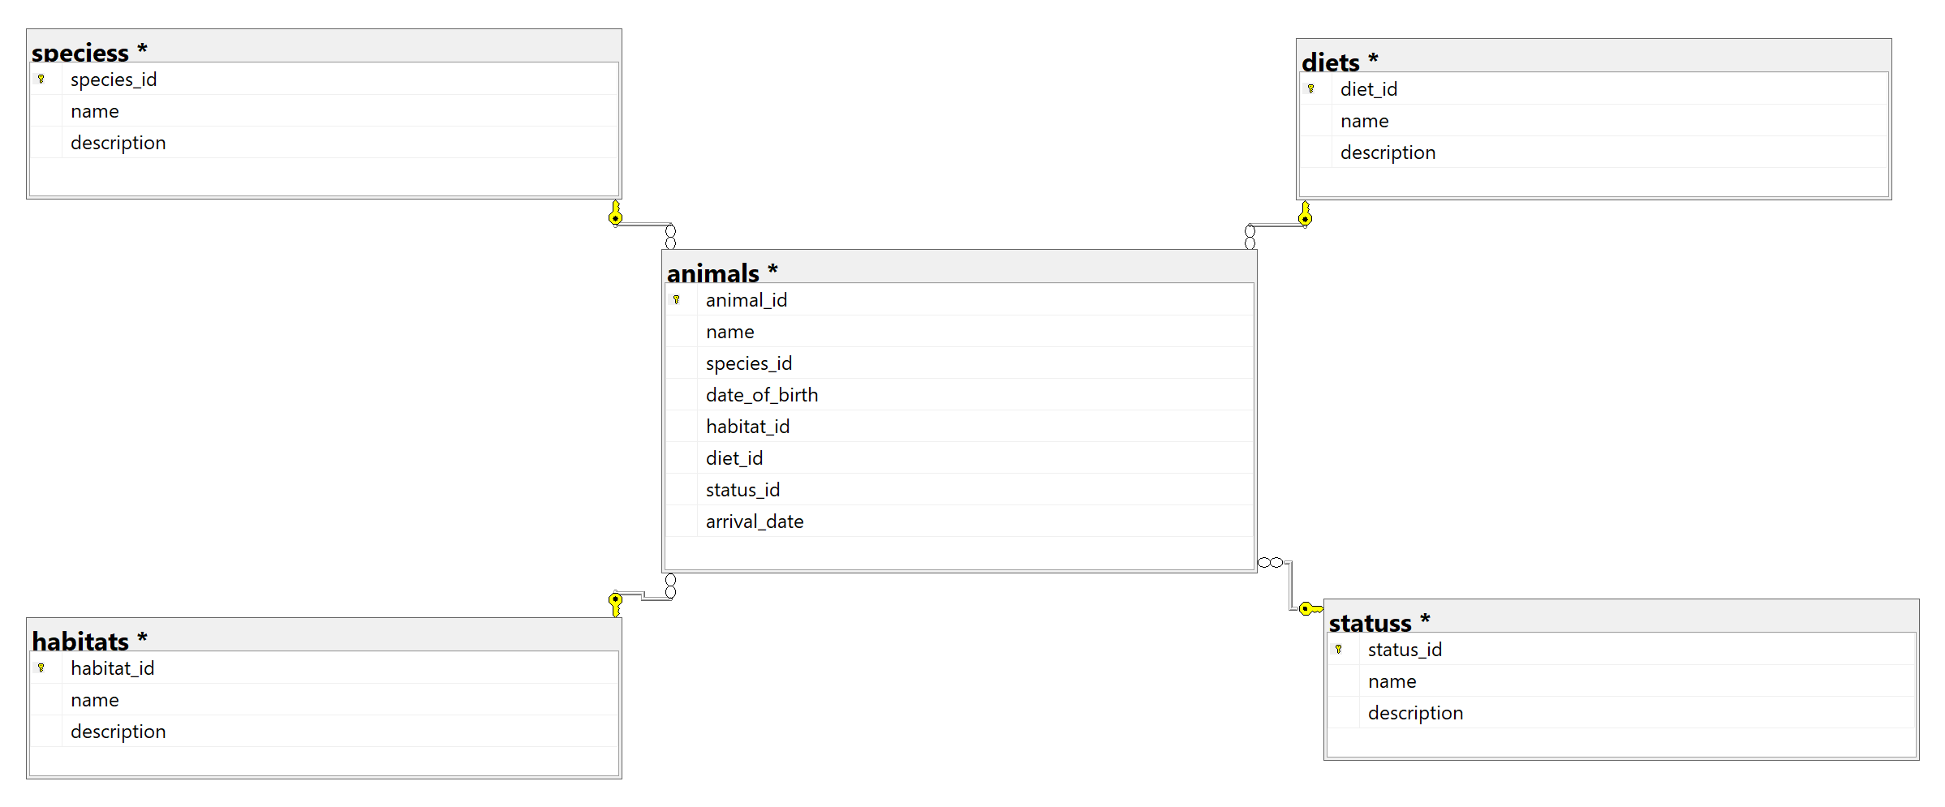

**TABLE / Animals**

|  |  |  |  |
| --- | --- | --- | --- |
|  | TYPE | KEY | Remarks |
| Animal Id | Integer | PK |  |
| Name | String |  |  |
| Species Id | Integer | FK | TABLE / SPECIESS |
| Date of Birth | Date |  |  |
| Habitat Id | Integer | FK | TABLE / HABITATS |
| Diet Id | Integer | FK | TABLE / DIETS |
| Status Id | Integer | FK | TABLE / STATUSS |
| Arrival Date | Date |  |  |

**TABLE / Speciess**

|  |  |  |  |
| --- | --- | --- | --- |
|  | TYPE | KEY | Remarks |
| Species Id | Integer | PK |  |
| Name | String |  |  |
| Description | String |  |  |

**TABLE / Habitats**

|  |  |  |  |
| --- | --- | --- | --- |
|  | TYPE | KEY | Remarks |
| Habitat Id | Integer | PK |  |
| Name | String |  |  |
| Description | String |  |  |

**TABLE / Diets**

|  |  |  |  |
| --- | --- | --- | --- |
|  | TYPE | KEY | Remarks |
| Diet Id | Integer | PK |  |
| Name | String |  |  |
| Description | String |  |  |

**TABLE / Statuss**

|  |  |  |  |
| --- | --- | --- | --- |
|  | TYPE | KEY | Remarks |
| Status Id | Integer | PK |  |
| Name | String |  |  |
| Description | String |  |  |

# Developer

# Tools

* Microsoft Visual Studio 2022 CE
* Microsoft SQL Server Express Edition 2022
* .NET Framework 8.0